8.31: Use conservation of the horizontal component of momentum to find the velocity of the combined object after the collision. Let +x be south.
P is constant gives
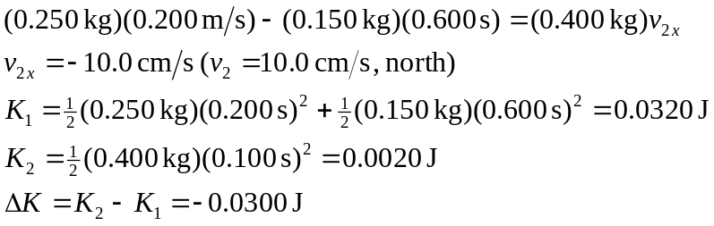

Kinetic energy is converted to thermal energy due to work done by nonconservative forces during the collision.

